Instructions for using the ILDS Statistics Feature

The statistics feature is available on the ILDS website at www.illinoisdelivers.net. This feature includes export options which will allow you to do customized analysis of your data.

The tab for this feature can be found at the top of the ILDS home page, next to the Manifests tab.
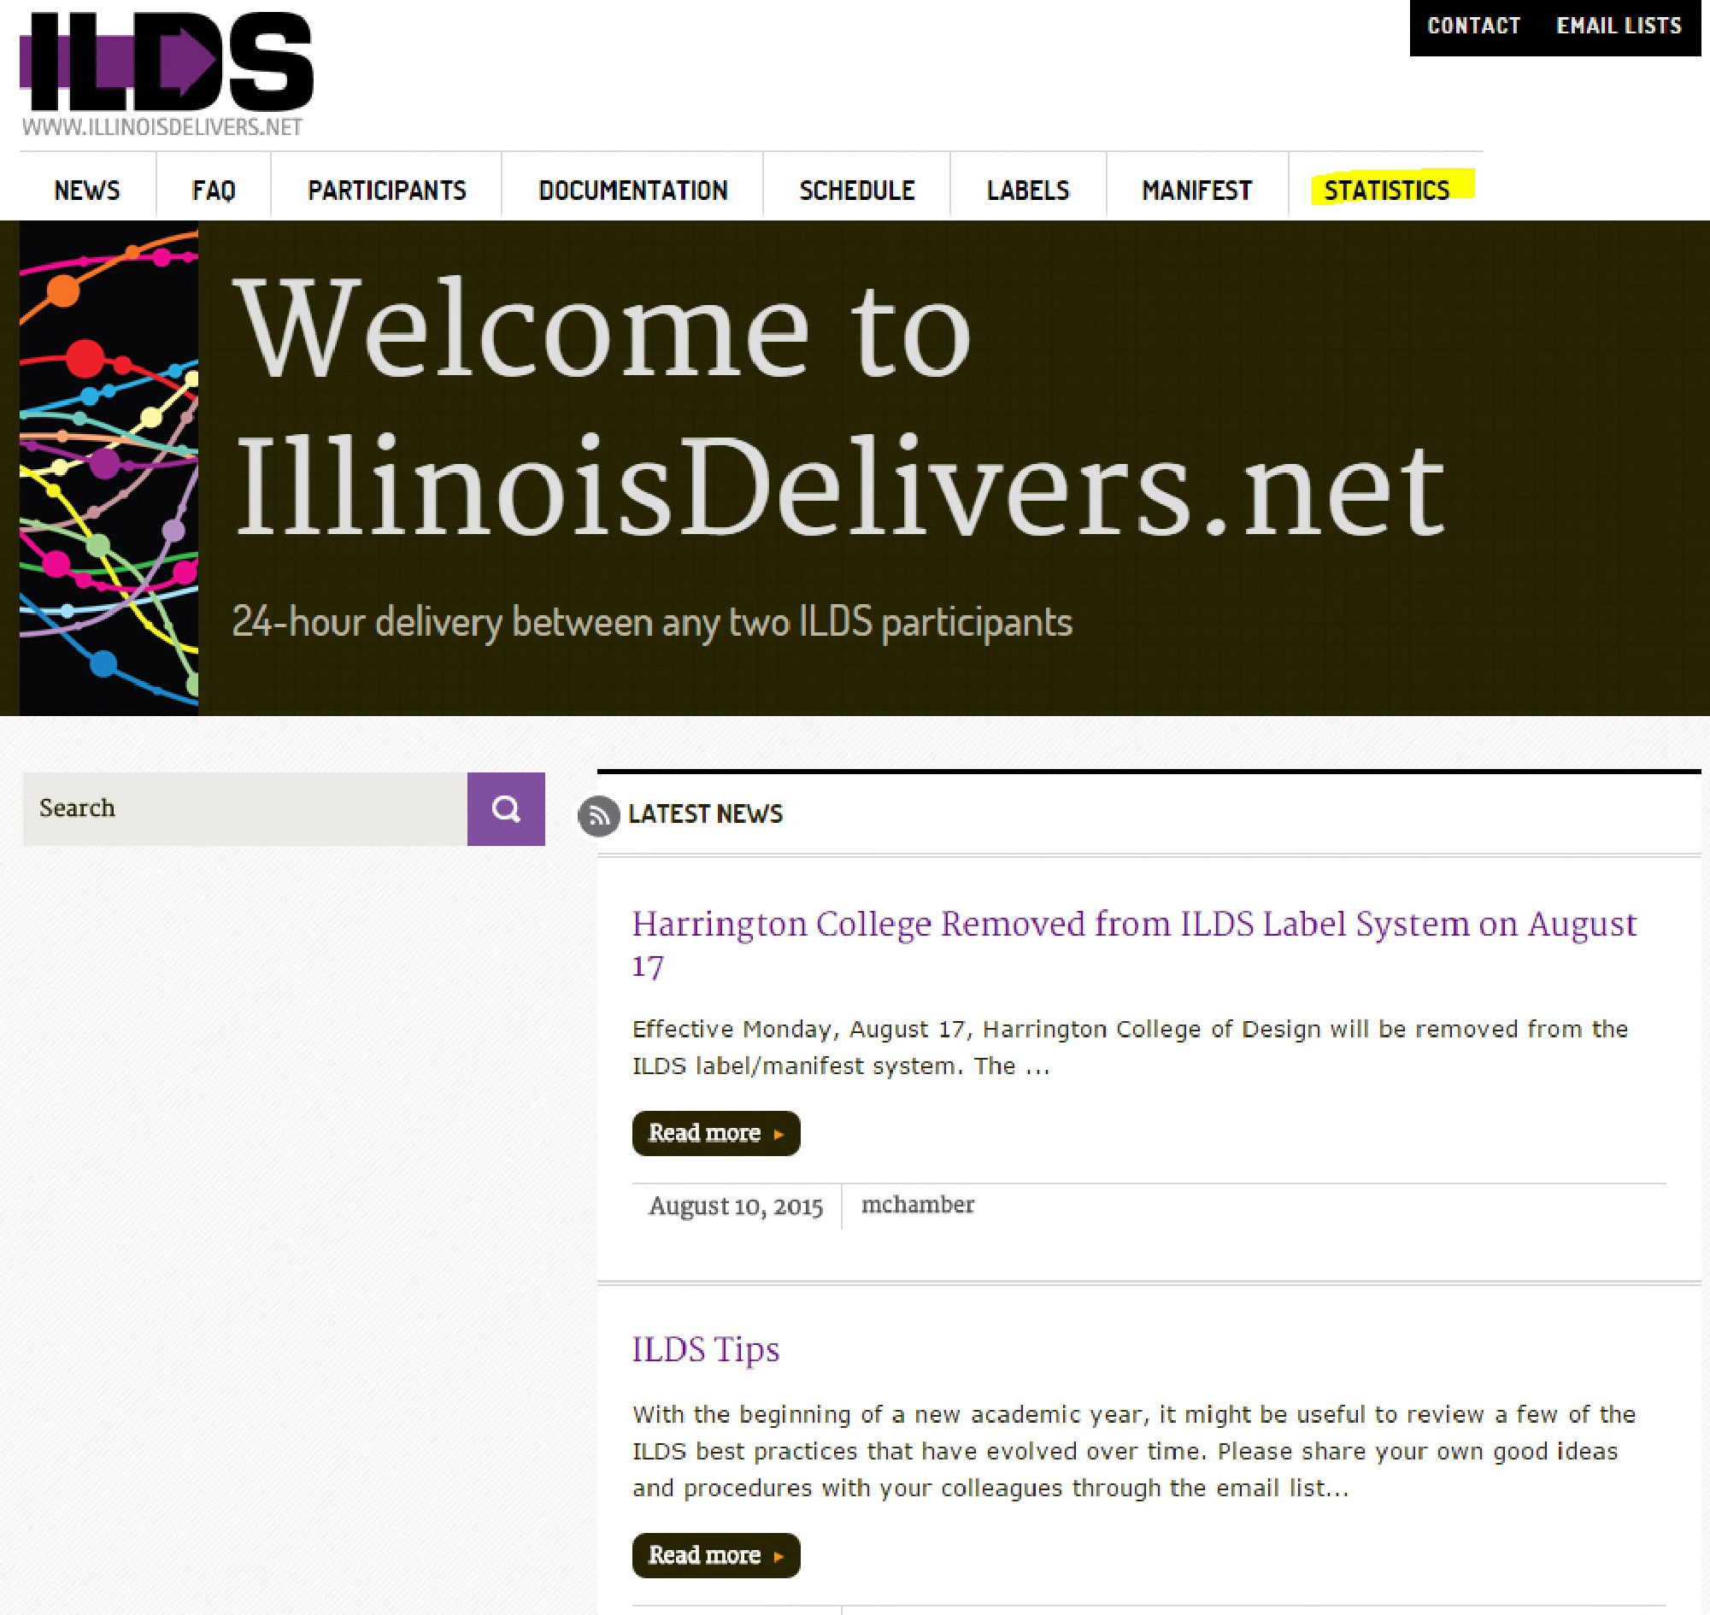

After clicking on the Statistics tab, the following screen will appear.

1 February 2026

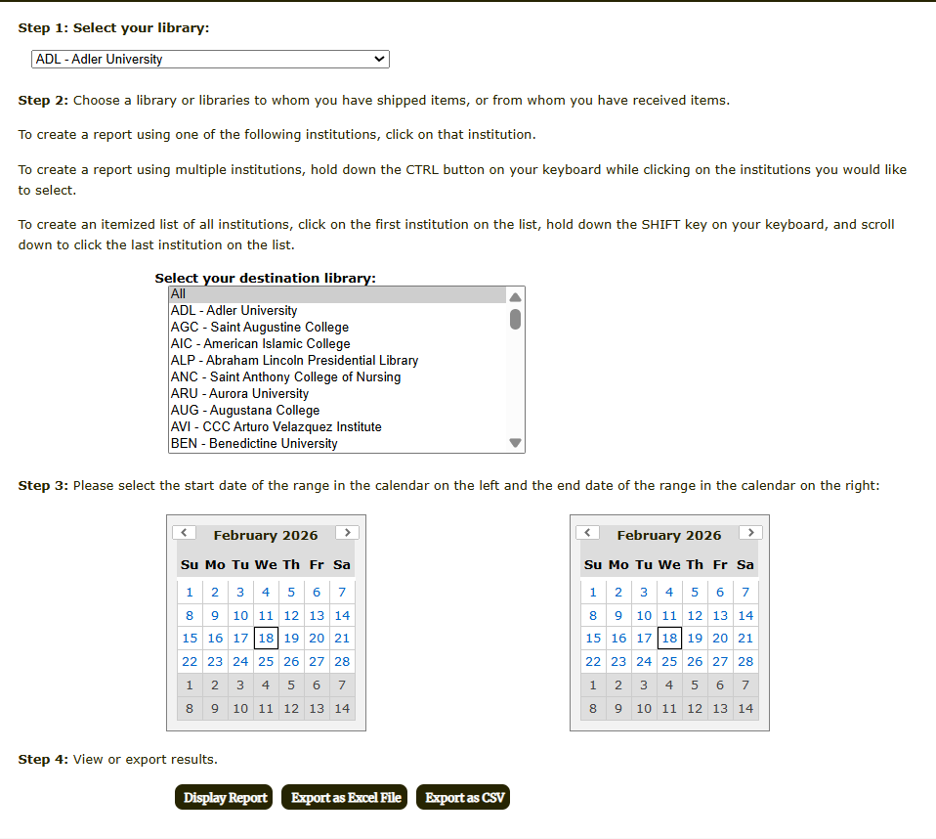

Follow these steps to retrieve statistics for your institution.
Step 1: Select your institution from the dropdown menu. We will use Bradley University for this example.
Step 2: In the next dropdown menu, select the destination institution. You can select one institution, multiple institutions, or “All” institutions. The “All” selection is the first selection in the list. To select multiple institutions, hold down the control (Ctrl) button on your computer keyboard as you click on each site you would like to see information for. For this example, we will select the first six locations in the dropdown.

2 February 2026

Step 3: In the calendar box on the left side of the page, click on the START date of the date range you would like to see statistics for. In the calendar box on the right side of the page, click on the END date of the range. Please select an END date prior to today’s date. For this example, we are selecting a start date of November 24, 2025 and an end date of November 28, 2025. The screen will look like this after you complete Steps 1 – 3.
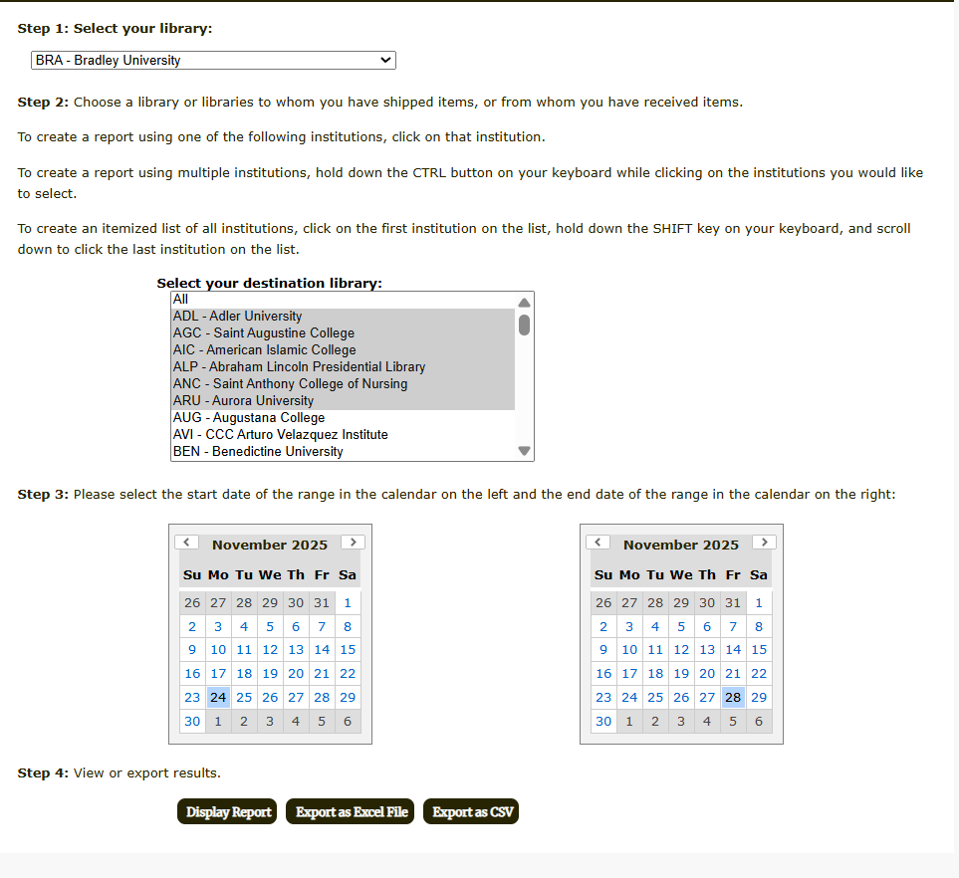

Step 4: This is where you will decide whether you want to display the information or export the information into an Excel (.xls) or Comma Separated (.csv) file. To display the report, click on Display Report. The following screen will appear.

3 February 2026

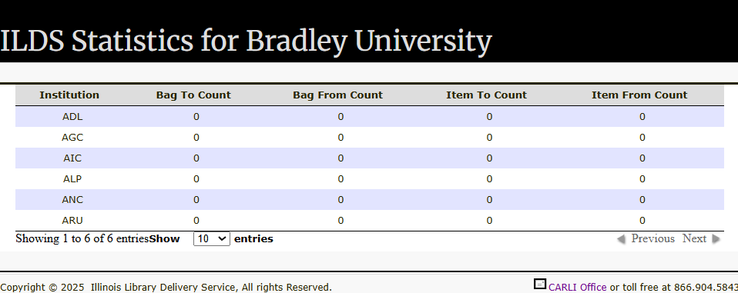

The ILDS 3-letter code in the first column identifies the destination for which you are viewing results. The next four columns provide information on the number of bags and items sent to and from each of the destination institutions that we selected.
Please note when selecting “All” in the destination dropdown, you will see the total number of bags and items sent to and from all ILDS locations for the date range you select, not a listing by individual destination.
Please send any questions related to the ILDS Statistics feature to support@carli.illinois.edu.

4 February 2026

