
Illinois Library Delivery Service
Participant Location Instructions
January 2026

Audience of this document
This document is written for Illinois libraries and the two library system headquarters that are direct delivery locations on the Illinois Library Delivery Service (ILDS). Libraries that are not ILDS direct delivery locations should consult with their library system for instructions on delivery service provided by their system.

ILDS
ILDS is the Illinois Library Delivery Service. On January 2, 2008, ILDS began providing interlibrary loan delivery service in Illinois. The locations served by ILDS are listed at http://www.illinoisdelivers.net/memlist. ILDS is funded by the Illinois State Library, with program management provided by the Consortium of Academic and Research Libraries in Illinois (CARLI), and trucking/courier services provided under contract with Reaching Across Illinois Library System (RAILS) and the Illinois Heartland Library System (IHLS).

ILDS locations and non-ILDS locations
Not every Illinois library, or even every academic library, is an ILDS direct delivery location. The list of ILDS participants is posted at: http://www.illinoisdelivers.net/memlist and is included in the drop-down menus on the ILDS web-based label system.

Illinois libraries that are not direct ILDS locations receive their direct delivery through their library system’s delivery service. ILDS interconnects the Illinois library systems’ delivery services. The library system locations serve as transfer points in the ILDS system for materials traveling to or from points not directly served by ILDS delivery. Therefore:

Materials traveling between any two ILDS locations in any library system (even if they are in the same library system) travel point to point in ILDS only.

Materials traveling between two non-ILDS libraries that are in the same system travel in their system’s own delivery system only.

Materials traveling between an ILDS and a non-ILDS library that are in the same system usually travel between the ILDS library and its system headquarters in ILDS, and between the system headquarters and the non-ILDS library in system delivery.

Materials traveling from an ILDS library to a non-ILDS library that are in different systems travel from the ILDS library to the non-ILDS library’s system headquarters in ILDS, and then on to the non-ILDS library in its system delivery service.

Materials traveling from a non-ILDS library to an ILDS library that are in different systems travel from the non-ILDS library to its system headquarters in system delivery, and then on to the ILDS library in ILDS.

This can be very confusing, so we’ve prepared a “Delivery Workflow” reference chart that is located at the end of this document. See Appendix 1.

Reminder: To find out which library system a library is a member of, refer to the Illinois State Library’s directory at http://www.librarylearning.info/libraries/.

ILDS service schedule
ILDS serves every location 5 days a week, Monday through Friday, except for the following holidays:
New Year’s Day, Martin Luther King Jr. Day, Memorial Day, Juneteenth, July 4th, Labor Day, Thanksgiving Day, the day after Thanksgiving Day, Christmas Eve, Christmas Day and New Year’s Eve. Your library will receive service every day; there is no need to call for pickup. If your library is closed on a day when service would be provided, you may inform the ILDS program coordinator by sending email to support@carli.illinois.edu.

Requesting interlibrary loan materials and processing requests for your materials
ILDS does not change how your library creates or receives interlibrary loan requests or how you enter the request status in your circulation or interlibrary loan system. Items being loaned should be accompanied by any request paperwork that will be needed by the borrowing library.

Reminder: All items traveling in library delivery systems must have permanent property markings on the item and/or the item’s own case that identify the owning library so that the item may be returned if its paperwork is lost. A barcode label or stamp is an example of this kind of mark.

Overview of the process
First, you will gather and bag your outgoing items by destination. Next, you will use the ILDS web based label system to create labels for each bag. Once you have your bags labeled, you will use the ILDS manifest system (which is a part of the web based label system) to approve the “manifest” that summarizes your entire outgoing shipment. The delivery vehicle arrives at approximately the same time every day. The driver will deliver your incoming shipment and pickup any outgoing shipment.

Supplies and equipment
You will need a computer with an Internet connection, a Web browser, software that can open PDF files such as Adobe Reader; a printer and standard 8.5 x 11” paper; scissors or paper cutter; and a supply of ILDS bags. ILDS best practice recommends “locking” each bag with a zip tie (cable tie); wire cutters make removing zip ties easy and safe. CARLI provides delivery bags. All other supplies are to be provided by the library.

ILDS bags
There are two types of ILDS bags: two sizes of purple zippered bags and blue padded media mailers. The zippered bags have a window slot to hold their delivery label and are used to ship items through ILDS.

The reusable blue padded media mailers are for providing additional protection when sending media materials from one ILDS direct stop to another ILDS direct stop. The DVD or CD is inserted into the blue media mailer, then the blue media mailer is shipped inside one of the zippered ILDS bags mentioned above. Use a disposable padded envelope when sending materials to libraries that are not ILDS direct stops; the blue mailers are intended for use within ILDS only, as such, the library system headquarters that services the non-ILDS destination library will remove the media from the blue mailer before completing delivery.

Bag labels
Every time a bag is shipped in ILDS it must have a label with a unique number for that specific usage of that bag. The web label system automatically creates unique bag numbers for you, but it is helpful to understand the format of these ILDS bag numbers. If you are not able to connect to the ILDS web label system, you may need to create labels by hand. We have created offline backup label templates for you to use in these instances. Using the offline backup templates requires you to create and insert unique bag numbers following the format used by the web label system.

Bag number format
ILDS bag numbers follow this format: DATE-FROM-TO-BAG-ITEMS
The components of the number are described in detail, below:

The date is formatted as follows (YYYYMMDD). For example February 3, 2014 would be: 20140203
The date to use is the date on which you are creating the label. This is not necessarily the date on which the item will actually be picked up by the delivery truck. Pickup will often be the next business day.

The “from” and “to” are the sending and receiving ILDS destinations’ 3-letter ILDS codes. Use the 3-letter ILDS codes found at http://www.illinoisdelivers.net/memlist Please don’t use OCLC or other 3-letter codes.

The “bag” number is a count of bags going from your library to the ILDS destination in this shipment. It will be “1” unless you are sending more than one bag to a particular destination in the current outgoing shipment. If you are sending more than one bag, just increment this number by one for each additional bag to that destination.

The “items” field is the number of items in this particular bag.

Example 1:
A bag that is being labeled on February 3, 2014, that is going from Augustana College (AUG) to Western Illinois University (WIU), which is the only bag Augustana is sending to Western in that shipment, and which contains 3 items, would have this bag number:
20140203-AUG-WIU-1-3

Example 2:
UI Urbana (UIU) is sending 3 bags of items to Greenville College (GRN) on February 4, 2014. These bags contain 6, 8, and 4 items respectively. Their bag numbers would be:
20140204-UIU-GRN-1-6
20140204-UIU-GRN-2-8
20140204-UIU-GRN-3-4

Computer software requirements
The ILDS web label system uses a web browser to create PDF files for printing. The browser must be set to allow pop-ups, accept cookies, and support Java Script. Labels and manifests will open in another window/tab in your browser. If you have trouble seeing or printing the PDF, try printing again, watch the browser tool bar at the top of the screen and check to see if it is displaying a warning message about pop-ups. If so, set the browser to allow pop-ups from the ILDS website.

Bagging items
Gather your outgoing items and sort the items by their ILDS destination. No sorting distinction needs to be made between items being loaned or returned to a specific destination. Loans and returns going to the same destination may be packaged in the same ILDS bag. Use a separate bag for each ILDS location. Bags going to library systems headquarters may, and often will, hold items going to multiple non-ILDS libraries in that system.

It is strongly recommended that you use a plastic cable tie (also called a “zip tie”) to secure the bag. Run the zip tie through the grommets and zipper on the top right of the purple zippered bags. Leave some slack in the zip tie to allow the receiving library to more easily cut the tie. As the receiving library will have to cut the zip tie to open the bag, which shows that the bag has not been opened in transit. Zip ties are not reusable.

Create bag labels
Reminder: You must use a new label with a unique bag number each time a bag is used.
Do not cross out information on an old label and reuse it.

- Connect to the ILDS web labels system

Point your browser to: http://www.illinoisdelivers.net/labels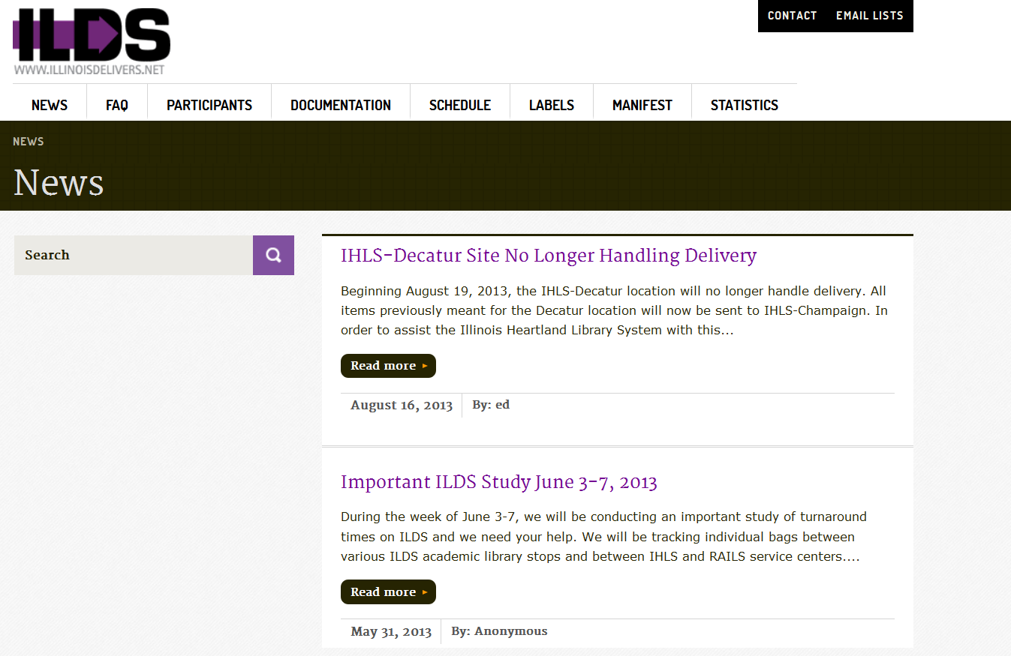
Figure 1 The ILDS “home” screen. Click on “Labels” to start creating labels. You do not need to login to create labels.
- Select your library

Select your library from the drop-down menu labeled “Select your library.” To scroll more quickly down this list, enter the first letter or letters of your library’s three letter ILDS code.

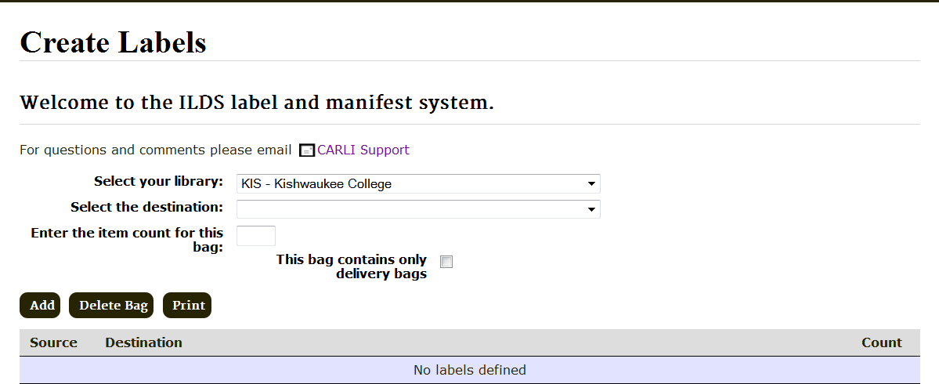
Figure 2 Select your library from the “Select your library” drop-down menu. We are Kishwaukee College in this example. Kishwaukee’s ILDS code is “KIS”.

- Select the destination library

From the menu labeled, “Select the destination,” select the destination library for the first bag. To scroll more quickly down this list, enter the first letter or letters of the destination library’s three letter ILDS code.

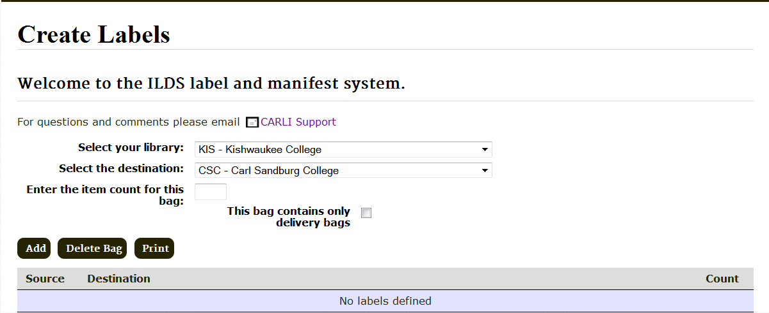
Figure 3 Select the destination library from the drop-down menu. Kishwaukee College is sending this bag to Carl Sandburg College. You can navigate more quickly down the drop-down menu by typing the first letter(s) of the destination library’s 3-letter ILDS code.

Reminder: If the final destination is an Illinois library that is not an ILDS location, select the destination’s library system headquarters as the destination in the web label system.
You can look up any Illinois library’s system membership in the Illinois State Library’s online directory at http://www.librarylearning.info/libraries/. The final destination for the item must be noted on the paperwork with the item. The paper ILDS label can be used to for this. If you are sending an item to a library that receives its delivery as part of a CDP, include the location where delivery is received in the CDP Delivery Information (TO) field.

For copies of the paper label, see: http://www.illinoisdelivers.net/sites/files/PaperILDSlabel.pdf.

Reminder: Please use best practice conservation and shipping practices when attaching any labels or other request or return address forms to books and other items being shipped.

- Enter the item count

Enter the number of items in the bag going to the selected destination and click “Add.” The display will update to show the source, destination, and item count for the new bag (See Figure 4 for example).

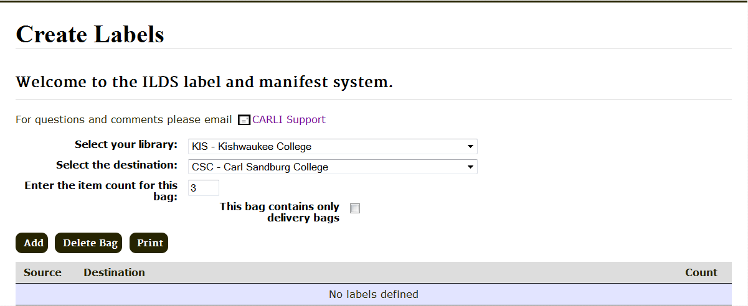
Figure 4 Enter the number of items in this bag going to this location.

- Enter the entire shipment bag by bag

Continue adding bags to the label system until you have entered your entire outgoing shipment. If you are sending a bag that contains only delivery supplies, please check the box next to “This bag contains only delivery bags”. Review the list of bags shown on the screen. If there are no errors in the list of bags, you are now ready to print bag labels and then create a shipping manifest.

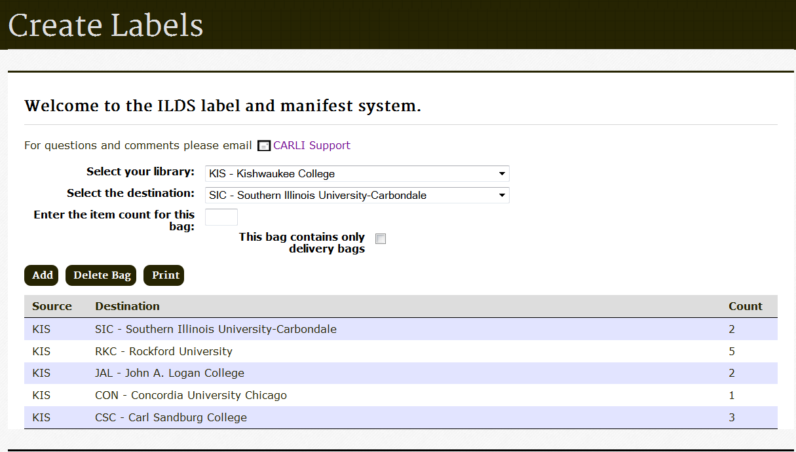
Figure 5 Continue creating labels until you have entered your entire shipment. When you are ready to print labels, click “Print” to create a PDF file of labels. The label PDF file may open in a separate window depending on what internet browser you are using.

If you enter incorrect bag information

Watch the display as you enter label information. If you note any errors, highlight the row containing the error and click “Delete Bag”. In this example, an error has been found with the bag going to SIC, so the first row has been highlighted for deletion.

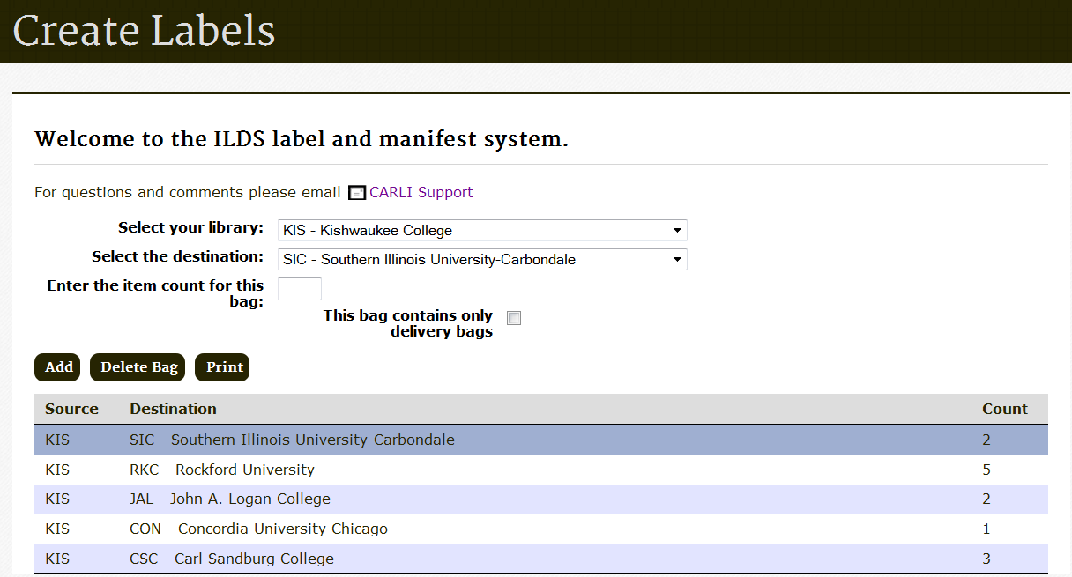
Figure 6 To delete a bag, select the row containing the bag you want to delete and click “Delete Bag”.
- Printing labels
Click “Print” to create the PDF file of labels to print. The PDF label may display in a different window or tab depending on what internet browser you are using. If you don’t see the labels, look at your internet browser toolbar and see if a “pop-ups blocked” message is displayed and if so, set your browser to accept pop-ups from this site.

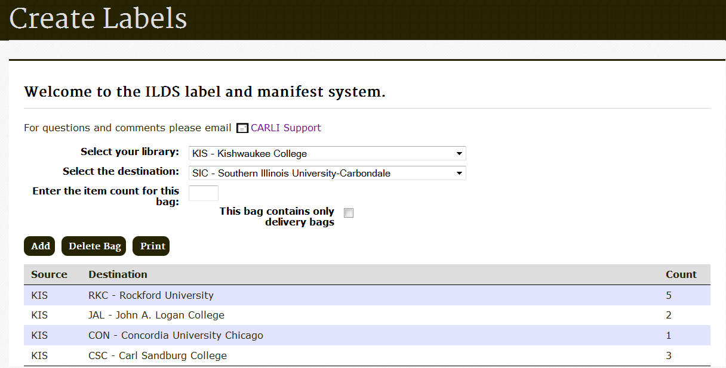
Figure 7 See print button highlighted in screenshot above

- ILDS bag label PDF file

The label PDF file will display. Open the file with Adobe Reader (or another PDF application such as Preview).

Use the Print command in Adobe Reader to print the file. (Click File and Print in the Adobe menu, then Print in your printer menu.) Up to six labels will print on an 8.5 x 11” page. If you do not wish to print all the labels in the PDF file, you may review the PDF file and select to print only the pages needed.

Alternatively, you may save the file to your computer and print later. If you save the file to print it later, make a note of the file name and location

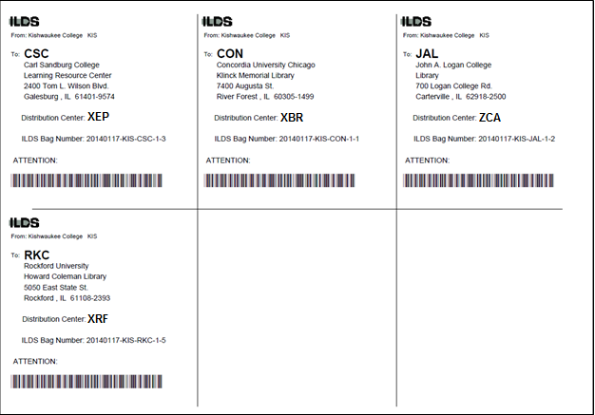
Figure 8 Labels will be created 6 per page. You may save the label file to your computer, or print now.

- Label the bags

Remove and discard any old labels that might be in the label sleeves. Cut the labels you printed along the lines and insert them in the window pouches in ILDS zipper bags.

Create an outgoing shipping manifest
After you have created and printed all the bag labels for the day’s shipment, you will create a manifest that summarizes the number and destinations of the bags being shipped in ILDS from your location in the current shipment. Typically, a library will create only one manifest per day, but it is possible to create additional manifests if needed (e.g., if something was left off the first manifest).

- Click on the “Manifests” tab to begin working with your outgoing manifest.
- Login to the manifest system

Each library’s login is currently their 3-letter ILDS code and the password for all users is “ilds” (omit quotes). Please note that the password must be entered in all lower case.

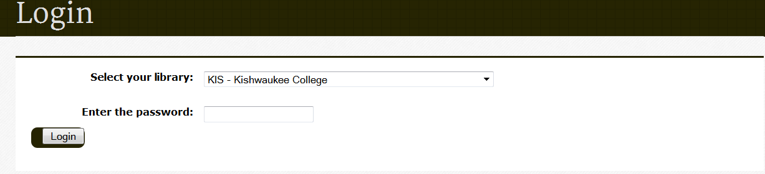
Figure 9 Click on the “Manifest” tab to proceed to printing the outgoing manifest. Login to begin. There are two sections under the “Manifest” tab, an Approve Manifest section, a View/Print Outgoing (see Figure 10 below). Since we are working with your outgoing manifest.

After labels are printed, you are ready to approve the outgoing manifest. The information you entered for labels will be used to create the manifest. You do not need to enter it again.
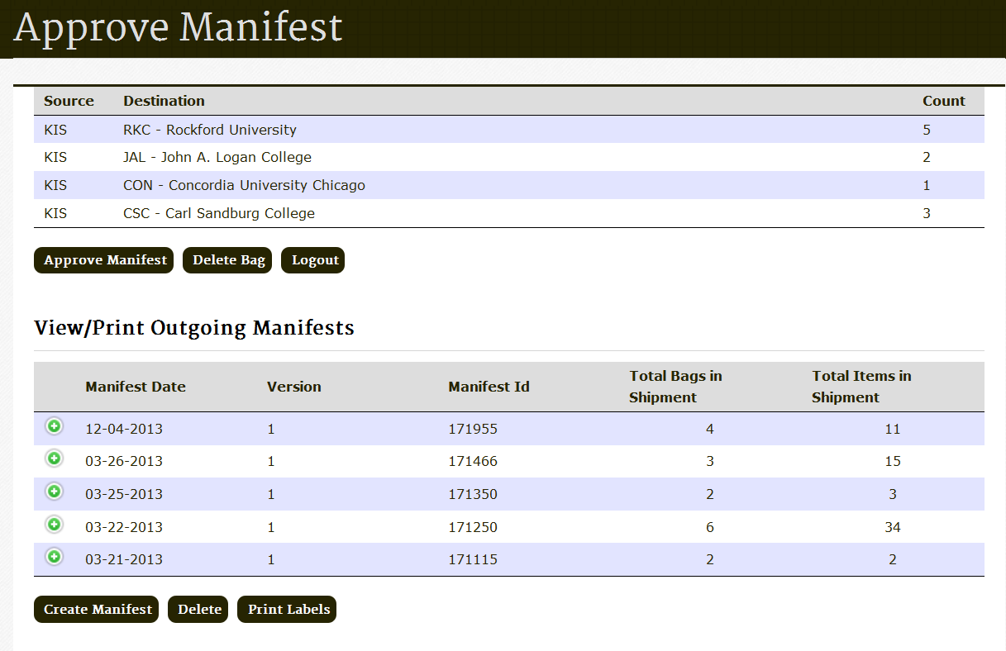
Figure 10 Manifest tab
- Review the manifest and edit (if necessary)

Logging into the manifest system will display the three sections shown above in Figure 10. Compare the “Approve Manifest” section list to the bags to be shipped. If there are errors in any of the bags’ sources, destinations or item counts; delete the bag(s) with the error(s). If an omitted or deleted bag needs a new label, create new label(s) by clicking the “Labels” tab at the top of the page. Remember to print any additional labels.

When the manifest list is accurate and complete, click “Approve Manifest” to create a PDF file of the manifest.

- Manifest approved confirmation

After approving a manifest you will see a confirmation message. Click “OK” to proceed. The manifest information you just approved is now available to print under the “Outgoing Manifest” section of the screen.

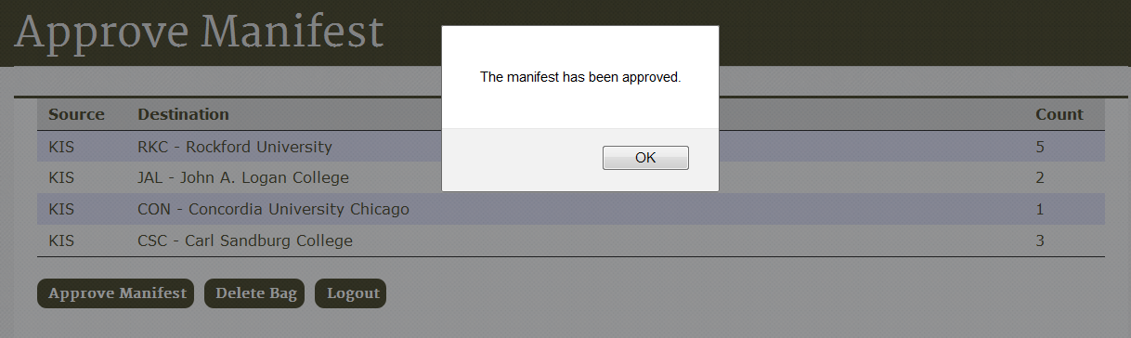
Figure 11 The manifest is approved.

Note: You are not required to put a printed copy of your manifest with your outgoing shipment. However, it is necessary that you complete the step of approving the manifest in order for the statistics to be gathered. See the next page if you want to keep printed copies of the manifest, or put printed copies with your outgoing shipment.

- Select the manifest to print

The ILDS web labels system will store the last several manifests created by your library. The newest manifest will be displayed at the top of the list. Manifests can be distinguished by their date. If more than one manifest is created in a day they can be distinguished by an incremental number to the right of the date, with the higher number being the later manifest.

To print your outgoing manifest, click on the corresponding row and click “Create Manifest.”

Reminder: If you create more than one manifest in one day, you must print all of them to reflect the entire shipment.

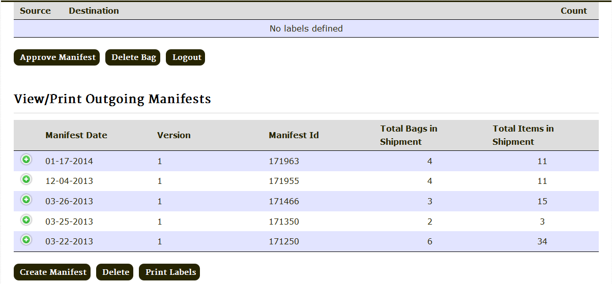
Figure 12 In this example the row for the manifest dated 01-17-14 is highlighted because that is our outgoing manifest for today. If you create more than one manifest in a day, the version number that displays to the right of the date will increment with each manifest. Normally, you will create only one manifest in a day, but this allows you to add a last minute item to your shipment, should you need to do so.

If you determine at this point that you have made a mistake on the outgoing manifest or the associated labels, click on the corresponding row, and then click on “Delete”. Please note that this will also delete all of the labels associated with this manifest so you will have to create labels again for each bag.

Clicking on the green + next to a Manifest Date will list the source, destination and item count for the associated manifest.

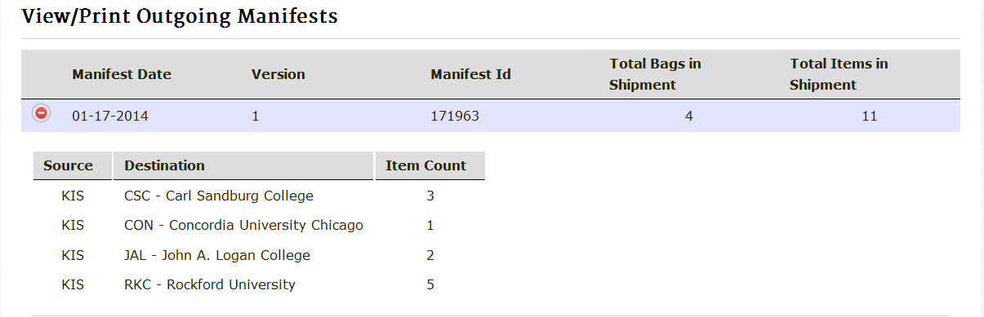
Figure 13 Clicking on the green (+) next to a Manifest Date will list the source, destination and item count for the associated manifest. To hide the list, click on the red (-).

- ILDS Outgoing Manifest PDF file

The outgoing manifest PDF file will display. You can print a copy of the manifest from this screen. Use the Print command in Adobe Reader to print the file. (Click File and Print in the Adobe menu, then Print in your printer menu.) Alternatively, you can save a copy of the manifest as a PDF for your records.

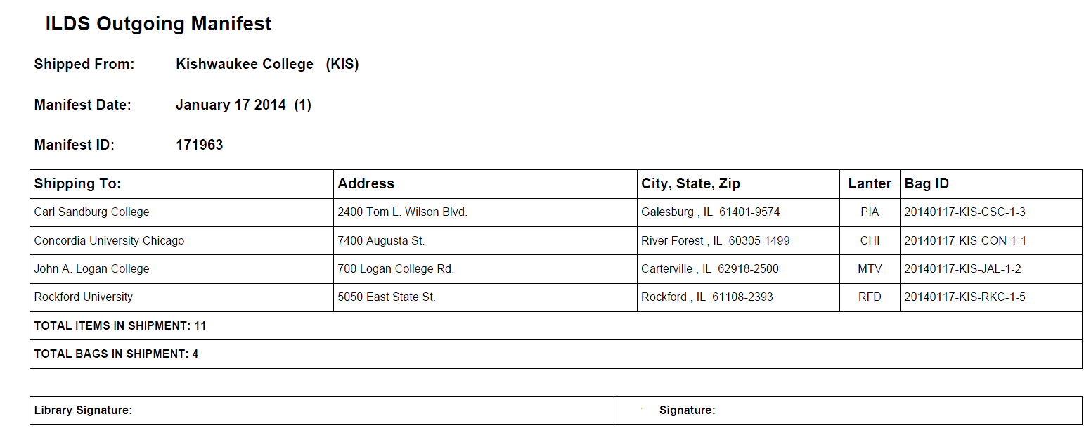
Figure 14 The outgoing manifest PDF file.

Reminder: You do not call to request a pickup. The delivery contractor will visit each ILDS location every business day (Monday through Friday, except holidays). Also, do not call to cancel service on days on which you are not sending anything. The delivery contractor will stop at your location every day and bring you any incoming items. If there are no items, they will proceed on to their next location.

ILDS Troubleshooting
You printed an incorrect label, had a printer problem, or lost the label…
Discard/recycle the bad label. Go to the Labels Home screen, then add and print the correct label. If you have not finalized your manifest, be sure not to delete any of the correct labels from the list. To reprint only the newly corrected label rather than all of the day’s labels, preview the file in your PDF viewer (usually Adobe Reader) and select the range of pages to print.

You approved your manifest, and then found more items to be shipped…
Keep the outgoing manifest you have already created and start a second manifest for the additional bags. Create and print the additional labels you need, and then create the second manifest for these additional bags and attach it to the manifest you created earlier.

You have more items to insert in a bag that you have already labeled…
If you have not already finalized your outgoing manifest, you can follow the instructions under “You printed an incorrect label”, above. If you have finalized your manifest, start a new bag to the destination and follow the instructions under “You finalized your manifest, then found more to be shipped,” above.

You are out of bags…
Send an email to the ILDS-ig (ilds-ig@carli.illinois.edu) email list to request more bags. Supplies will be shipped to you in ILDS. You must be a member of the ILDS-ig listserv in order to post a message to it. You can subscribe to the listserv at http://www.illinoisdelivers.net/email-lists.

An item won’t fit into an ILDS bag…
Package the item into a secure and appropriately sized container, e.g., a map tube. Mark any containers you expect to be returned to you to indicate the return requirement and your institution’s name. Use the ILDS labels web based system to create a label for the item as if it was a single item in a bag to its destination. Attach the label to the container in a secure manner. Put the item with your outgoing shipment. Some items may not be suitable for shipping in ILDS. Please email support@carli.illinois.edu if you have specific questions.

The ILDS website is down or you cannot connect to it…
Label and manifest templates have been created that you may use during computer or network problems. The backup labels are located at http://www.illinoisdelivers.net/sites/files/backuplabels.pdf and the backup manifests at http://www.illinoisdelivers.net/sites/files/backupmanifest.pdf; the manifest is also available as an MS Excel file at http://www.illinoisdelivers.net/sites/files/backupmanifest.xls.

The backup labels are already addressed to each possible ILDS location. Make copies of the ones you need, and fill in your library’s 3-letter ILDS code and create a bag number. (See “Bag number format” at the beginning of this document.) A directory of all ILDS locations is available at http://www.illinoisdelivers.net/memlist. ILDS codes and library addresses are also available in the Illinois State Library’s directory at http://www.librarylearning.info/libraries/.

Your library is going to be closed for a planned period of time, has an emergency closure, is moving to another location, or has a new ILDS contact person…
Please email support@carli.illinois.edu.

ILDS Supplementary Materials

Paper ILDS Routing Label
This is primarily used by non-ILDS libraries sending items to ILDS libraries or to non-ILDS libraries in a different regional library system. See http://www.illinoisdelivers.net/sites/files/PaperILDSlabel.pdf.

ILDS Bag Label Offline Backup Templates
Used when either the ILDS label system is down or you are unable to connect to it.
For labels see:
http://www.illinoisdelivers.net/sites/files/backuplabels.pdf

For the manifest template see:
http://www.illinoisdelivers.net/sites/files/backupmanifest.pdf

Library Directories
ILDS locations see: http://www.illinoisdelivers.net/memlist

For all Illinois libraries see: http://www.librarylearning.info/libraries/

For Assistance, Questions, Change of Address, or to Report Closures
Contact CARLI at support@carli.illinois.edu or call toll-free: (866) 904-5843

Appendix 1

Illinois Library Delivery Workflow Chart

Use the chart on the next page to help you determine how to label and send materials to other Illinois libraries in various lender/borrower scenarios.

For all scenarios, the following apply:

- Make sure your library’s materials have permanent property markings identifying your library.
- Process any interlibrary loan (ILL) requests or return transaction(s) in your ILL system and/or circulation system as needed to reflect the items’ status.
- Place the request paperwork from your interlibrary loan system inside or with each item.
- Use best practice conservation techniques when attaching any paperwork or labels to items.
- Use L2 Library Learning at http://www.librarylearning.info/libraries/ to determine an Illinois library’s address, Community Delivery Partnership (CDP) information, or ILDS 3-Letter Code or ILDS 3-Letter Code. ILDS locations are also listed at http://www.illinoisdelivers.net/memlist.
- Use a separate ILDS bag for each ILDS destination in your shipment.
- Consult with your regional library system about any questions regarding their system delivery service.
- Contact CARLI support for any questions about ILDS: support@carli.illinois.edu

Item from | Final Destination | Labeling and Shipping Instructions
ILDS location | Any other ILDS location in any Illinois regional library system | These items do NOT need paper ILDS routing slips.  Place the item in an ILDS bag with any other materials you are sending to the same ILDS destination. Create a bag label in the ILDS web label system, label the bag, and send the bag with your ILDS shipment.
ILDS location | Non-ILDS Illinois location in a different Illinois regional library system | Each item WILL need a paper ILDS routing label, available at: http://www.illinoisdelivers.net/sites/files/PaperILDSlabel.pdf. On this label, fill in the “Final Destination,” with the name of the non-ILDS library receiving the item, and the “From” field with the name of your library. Circle or highlight the ILDS code for the regional library system of the Final Destination library on the left side of the label. If you are sending an item to a library that receives its delivery as part of a CDP, include the location where delivery is received in the CDP Delivery Information (TO) field. Place the item in an ILDS bag with any other materials you are sending to the same regional library system headquarters. You may put items going to different non-ILDS libraries in the same regional library system in the same bag. Create a bag label in the ILDS web label system, using the Final Destination libraries’ regional system as the destination. Label the bag, and send the bag with your ILDS shipment.
ILDS location | Non-ILDS Illinois location in the same Illinois regional library system | Note: Unless your library system has informed you of an alternate procedure for sending materials within your system, follow these instructions.  Each item WILL need a paper ILDS routing label, available at: http://www.illinoisdelivers.net/sites/files/PaperILDSlabel.pdf. On this label, fill in the “Final Destination,” with the name of the non-ILDS library receiving the item, and the “From” field with the name of your library. Circle or highlight the ILDS code for the regional library system of the Final Destination library (in this case, this is also your regional library system) on the left side of the label. If you are sending an item to a library that receives its delivery as part of a CDP, include the location where delivery is received in the CDP Delivery Information (TO) field. Place the item in an ILDS bag with any other materials you are sending to your regional library system headquarters. You may put items going to different non-ILDS libraries within your regional library system in the same bag. Create a bag label in the ILDS web label system, using your regional system as the destination. Label the bag, and send the bag with your ILDS shipment
Non-ILDS location | Any ILDS location in any regional library system (even if it is the same system) | Each item WILL need a paper ILDS routing label, available at: http://www.illinoisdelivers.net/sites/files/PaperILDSlabel.pdf. On this label, fill in the “Final Destination,” with the name of the ILDS library receiving the item, and the “From” field with the name of your library. Circle or highlight the destination library’s ILDS code on the right side of the label. Send the item to your regional library system in your system delivery service for them to route on to the destination location in ILDS.
Non-ILDS location | Non-ILDS location in a different Illinois regional library system | Each item WILL need a paper ILDS routing label, available at: http://www.illinoisdelivers.net/sites/files/PaperILDSlabel.pdf. On this label, fill in the “Final Destination,” with the name of the non-ILDS library receiving the item, and the “From” field with the name of your library. Circle or highlight the ILDS code for the regional library system of the Final Destination library on the left side of the label. If you are sending an item to a library that receives its delivery as part of a CDP, include the location where delivery is received in the CDP Delivery Information (TO) field. Send the item to your regional library system headquarters in your system delivery service for the system to route on to the destination location’s regional system in ILDS. The item will subsequently be routed to the Final Destination location via the destination library’s regional library system delivery.
Non-ILDS location | Non-ILDS location in the same Illinois regional library system | Consult with your regional library system about the label to use for intra-systems delivery. These items will be routed to the destination location in your regional library system’s delivery.
Any Illinois library | Any non-Illinois library | Not covered by this document. Contact your regional library system if you have questions.

